SIMATS ENGINEERING
ASSESSMENT TOOL I — Uncertainty Visualization Lab
Course: Data Handling and Visualization | Code: DSA0603 | CO: CO5
Duration: 180 min | Total Marks: 100 | Reg No : 192324275  Name: JAANA NITHISH
COURSE OUTCOME COVERED
CO3: Analyze time-series data, trends, associations, and uncertainty through appropriate visualization methods. (BL4)
Activity Tool : Uncertainty Visualization Lab Weightage: 20%

Code of Conduct:
I JAANA NITHISH (192324275) (Name / Reg No) certify that this submission is my original work and that I have adhered to the guidelines specified for this assessment. I understand that any violation of academic integrity rules will result in disciplinary action.
Signature of the student:
JAANA NITIHISH

Criteria | Understanding of Uncertainty  25% | Visualization of Uncertainty  25% | Application of Visualizatio n Principles  20% | Organizati on 20% | Accura cy 10% | Clar ity 5% | Tota l
Q1
Q2
Q3
Q4
Q5

Uncertainty Visualization Lab – Assessment Tool R Programming Practical Questions with Datasets
Instructions: Answer all five questions. Use R programming to construct the required
visualization, interpret uncertainty, and identify potential visualization pitfalls. Use the given data exactly unless a transformation is explicitly requested.

Q1. Bootstrapping and Confidence Intervals – Point Estimate

A quality-control team records the following delivery times (in minutes) for 12 randomly selected orders. Using R, calculate the sample mean and obtain a 95% bootstrap confidence interval for the mean using at least 5,000 bootstrap resamples. Visualize the bootstrap distribution and mark the observed mean.
Data: 31, 35, 28, 42, 37, 33, 45, 29, 39, 34, 41, 36

Expected R tasks: resampling, point estimate, confidence interval, histogram/density plot, interpretation.

Expected result

The sample mean is:

Mean = 35.83 minutes approximately

The exact bootstrap confidence limits can vary slightly because bootstrap samples are randomly generated. With set.seed(123), the result is reproducible.

Interpretation

- The observed average delivery time is approximately 35.83 minutes.
- The bootstrap distribution represents the sampling uncertainty around the estimated mean.
- The 95% bootstrap confidence interval gives a plausible range for the population mean delivery time.

- Only 2.5% of bootstrap means lie below the lower limit and approximately 2.5% lie above the upper limit.
- A narrow interval indicates relatively low uncertainty, whereas a wide interval indicates greater uncertainty.

Visualization pitfall

A common mistake is to interpret the bootstrap histogram as the distribution of the original delivery times. It is actually the distribution of resampled means.
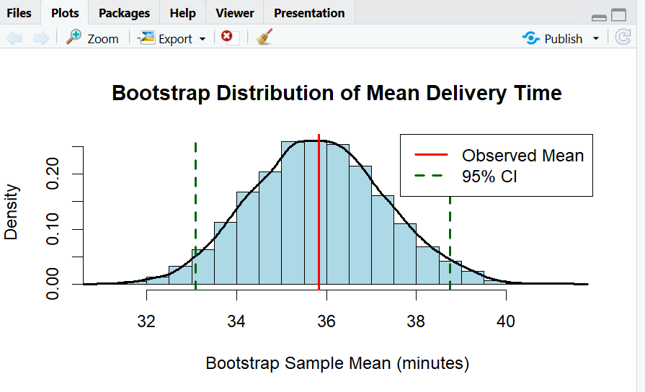

Q2. Uncertainty in Trend Estimation
The following data represent monthly advertising expenditure and sales. Fit a linear regression model in R to estimate the sales trend. Plot the observations with the fitted regression line and a 95% confidence band. Explain how the uncertainty changes across the range of advertising expenditure.
Data: Advertising = 10, 12, 15, 18, 20, 23, 25, 28, 30, 33, 36, 40;

Sales = 48, 51, 53, 57, 60, 61, 66, 69, 72, 75, 79, 84

Expected R tasks: lm(), prediction interval/confidence interval, ggplot2 visualization, trend interpretation.

Regression interpretation

The data show a positive relationship between advertising expenditure and sales.
As advertising expenditure increases, sales also tend to increase. The fitted regression line represents the estimated average trend. Confidence-band interpretation
The shaded region represents the 95% confidence interval for the estimated mean sales.
- The confidence band is generally narrower near the center of the observed advertising range.
- It becomes wider toward the edges, especially where there is less information supporting the estimate.
- This means predictions of the average sales become more uncertain near the boundaries of the data.

Important distinction

A confidence interval describes uncertainty about the mean response.

A prediction interval describes uncertainty about an individual future observation and is therefore wider.
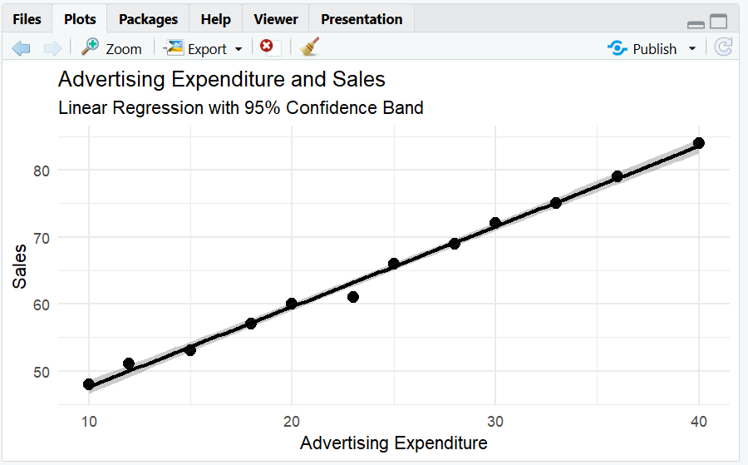

Q3. Overplotting, Jittering and Transparency
A survey records the number of hours studied and examination scores for 30 students. Several students have identical values. Create a scatterplot in R first without modification, then redesign it using partial transparency and jittering. Compare the two plots and explain how overplotting

affects interpretation.
Data: Hours = 2,3,3,4,4,4,5,5,5,5,6,6,6,6,6,7,7,7,7,7,8,8,8,8,8,9,9,9,10,10;

Scores =
45,52,52,58,60,60,64,66,66,66,70,72,72,72,72,76,78,78,80,80,84,84,85,85,85,88,9
0,90,94,94 Expected R tasks: geom_point(), alpha, position_jitter(), comparison of overplotting.

Original scatterplot:

- Some observations have identical Hours and Scores.

- Points may overlap.

- It becomes difficult to determine how many students have the same values.

- The number of observations can therefore be underestimated visually.

Redesigned scatterplot:

- geom_jitter() slightly moves overlapping observations.

- alpha = 0.5 makes overlapping points partially transparent.

- Dense regions become easier to identify.
- The underlying pattern becomes clearer.

Interpretation

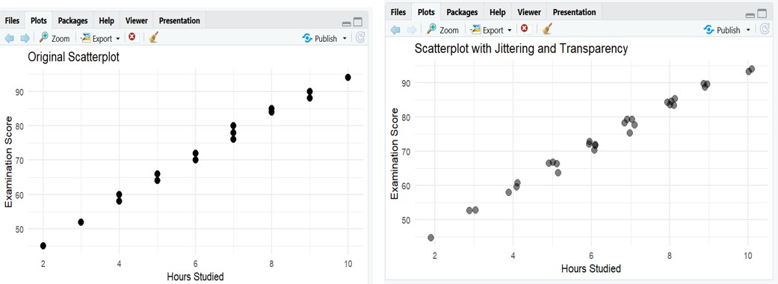
There is a clear positive relationship between study hours and examination score. Students who study more hours generally have higher examination scores.

Q4. 2D Histogram and Density Estimation

A researcher measures height and weight for 20 participants. Construct a 2D histogram and a 2D density visualization in R. Use the plots to identify regions with high observation density. State which visualization communicates concentration more clearly and justify your choice.
Data: Height = 150,152,155,158,160,161,163,165,166,168,170,171,173,175,176,178,180,182,184,186;
Weight = 48,50,53,55,57,59,60,62,64,65,68,69,71,73,74,77,80,82,85,88

Expected R tasks: 2D binning, density estimation, contour/density layers, interpretation of concentration.

Interpretation

The observations show a strong positive relationship between height and weight.
Higher concentrations of observations occur along the central diagonal region where height and weight increase together.
For example, many observations are concentrated approximately around:

- Height: 160–175 cm

- Weight: 57–73 kg 2D Histogram
The 2D histogram divides the graph into rectangular bins.

- Darker/more intense bins indicate more observations.

- It is simple and easy to understand.

- However, the result depends strongly on the selected number of bins.

2D Density

The density plot estimates the smooth concentration of observations.

- High-density regions are shown by stronger density levels.

- It provides a smoother representation than the histogram.

- It is useful for identifying the overall concentration pattern.
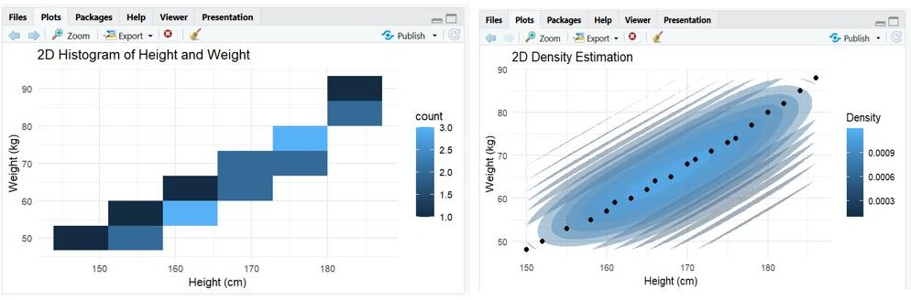

Q5. Color Scales, Accessibility and Misleading Visualization
The following category-wise satisfaction scores must be visualized in R. Create two plots: (1) a plot using a nonmonotonic/diverging color scheme that could mislead interpretation, and (2) a redesigned plot using an ordered, color-vision-deficiency-friendly sequential scale. Explain why the second design is more effective and identify the visualization pitfall in the first design.
Data: Category = A,B,C,D,E,F,G; Satisfaction = 42,48,55,61,67,74,82
Expected R tasks: color mapping, scale selection, accessibility-aware redesign, critique of misleading color use.

Plot 1 – Problem with the color scale

The first visualization uses a diverging color scheme:

- Blue represents lower values.

- White represents the midpoint.

- Red represents higher values.

The problem is that the data represent a single ordered quantity: satisfaction score.

There is no meaningful natural midpoint that divides the data into two different semantic categories.
The strong change from blue to red can therefore make moderate differences appear more important than they actually are.

Plot 2 – Improved design

The second visualization uses the Viridis sequential scale. A sequential scale is appropriate because:
42 < 48 < 55 < 61 < 67 < 74 < 82

The colors change progressively as satisfaction increases.
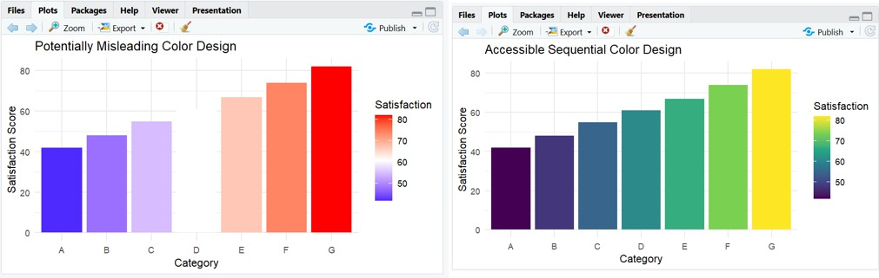

Suggested R packages: ggplot2, dplyr, boot (or base R).

Assessment focus: Correct R code, appropriate uncertainty visualization, interpretation, and identification of misleading design choices.

